Project Report
On
“Smart Resume Screener”

Submitted by
Dhangar Harshal Dhanraj
MCA I (Semester: II)

Guided by
“Dr. Manoj Sathe sir”

Assistant Professor, MCA Department

P.E. Society's
Modern Institute of Business Studies
(Autonomous)
Nigdi, Pune – 411044
2024-2025

Certificate

This is to certify that the Mini Project entitled “Smart Resume Screener” is submitted by Dhangar Harshal Dhanraj a Bonafide student of this institute, studying for a Master of Computer Application, has successfully carried out MCA semester-ⅠⅠ Mini Project documentation. This project report is submitted in partial fulfilment of M.C.A. Semester II (A.Y.2024-25) curriculum as per the Savitribai Phule Pune University norms.

Dr. Maithili Arjunwadkar
Director Internal Guide External Examiner
PES MIBS

ACKNOWLEDGEMENT

It is my proud privilege to express my profound gratitude to the entire management of Progressive Education Society’s Modern Institute of Business Studies and teachers of the institute for providing me with the opportunity to avail the excellent facilities and infrastructure of the institute. The knowledge and values inculcated have proved to be of immense help to my career.
I am grateful to Prof. Dr. Maithili Arjunwadkar (Director, MIBS) for their astute guidance, constant encouragement and sincere support for this project work.
I express my sincere gratitude to Dr. Manoj Sathe sir MIBS for their inspiration, constructive suggestion, mastermind analysis and affectionate guidance in my work, without which this project work completion would have been impossible for me. Sincere thanks to all my seniors and colleagues at the company for their support and assistance throughout the project.
I would like to thank all the faculties for providing me with an opportunity to pursue my industrial training, as it is an important part of the MCA course.
I feel proud and privileged in expressing my deep sense of gratitude to all those who have helped me in presenting this assignment. I would be failing in my endeavor if I do not place my acknowledgement.

Dhangar Harshal Dhanraj

INDEX
Title |  | PAGE NO.
CHAPTER 1: INTRODUCTION
1.1. | Abstract | 5
1.2. | Introduction of the project | 6
1.3. | Existing System and Need for System | 7
1.4. | Scope of Work | 9
1.5. | Environment - Hardware and Software | 11-12
CHAPTER 2: PROPOSED SYSTEM
2.1. | Proposed System | 13
2.2. | Objectives of System | 14
2.3. | User Requirements | 15-17
CHAPTER 3: ANALYSIS &DESIGN
3.1. | Entity Relationship Diagram (ERD) | 18
3.2. | Class Diagram | 19
3.3. | Use Case Diagrams | 20-22
3.4. | Activity Diagram | 23
3.6. | Table Design | 24-25
- Drawback sand Limitations |  | 26-27
- Proposed Enhancements |  | 28-29
- Conclusion |  | 30
- Bibliography |  | 31-32
- ANNEXURES: |  | 33
- ANNEXURE 1: USER INTERFACE SCREENS |  | 33-37

CHAPTER 1: INTRODUCTION

- Abstract:

The Smart Resume Screener is an innovative web-based application developed to revolutionize the traditional recruitment process by automating the initial stages of candidate screening. In today’s competitive job market, organizations often receive hundreds or even thousands of applications for a single position, making manual resume screening both time-consuming and prone to human error. This project addresses these challenges by utilizing advanced natural language processing (NLP) and machine learning algorithms to parse and analyze resumes uploaded by users.
The system efficiently extracts essential information from resumes, including candidates’ skills, educational background, work experience, and other relevant attributes. Recruiters can also create detailed job descriptions specifying the required qualifications, skills, and experience for open positions. The application then intelligently matches and ranks candidates against these job descriptions, providing recruiters with a prioritized list of the most suitable applicants.
By automating resume parsing and candidate-job matching, the Smart Resume Screener significantly reduces the manual workload for HR professionals, accelerates the hiring process, and ensures a more objective and data-driven approach to candidate selection. The user-friendly interface further enhances the experience, allowing recruiters to easily manage resumes, job descriptions, and candidate rankings. Ultimately, this project aims to improve the efficiency, accuracy, and fairness of the recruitment process, helping organizations identify and hire the best talent more effectively.

- Introduction and Objectives of the Project:
INTRODUCTION
Smart Resume Screener is an intelligent resume screening and job matching application designed to streamline and automate the recruitment process. The project leverages modern technologies including Natural Language Processing (NLP), machine learning, and web development to create an efficient and user-friendly platform for recruiters and hiring managers.

Objectives

  - Automate Resume Parsing:
Develop a system that can automatically extract relevant information such as skills, education, and work experience from uploaded resumes using advanced NLP techniques.
  - Candidate-Job Matching:
Implement algorithms to compare candidate profiles with job descriptions and rank candidates based on their fit for the role.
  - User-Friendly Interface:
Design an intuitive web interface that allows recruiters to upload resumes, create and manage job descriptions, and view ranked candidate lists.
  - Reduce Manual Effort:
Minimize the time and resources required for initial candidate screening by automating repetitive tasks.
  - Enhance Screening Accuracy:
Improve the quality and consistency of candidate shortlisting by leveraging data-driven, objective methods.
  - Support Data-Driven Decisions:
Provide recruiters with actionable insights and transparent ranking criteria to support fair and informed hiring decisions.

- Existing System and Need for System

- Existing System:

The Smart Resume Screener is a Flask-based web application that automates resume screening by parsing resumes (PDF/DOCX), managing candidates and job descriptions, and ranking applicants based on job requirements. It features secure user authentication with admin privileges, a resume parser to extract key candidate information (skills, experience, education), and a ranking module to match candidates to job descriptions. The system uses a MySQL database to store user accounts, parsed resume data, and job listings. A web interface allows users to upload resumes, manage data, and view rankings. Security measures include password hashing, session management, and secure file handling with temporary storage and unique filenames.

- Need for the System:
The system addresses several key needs in the recruitment process:
- Automation of Resume Screening:
- Reduces manual effort in reviewing resumes
- Provides consistent evaluation criteria
- Saves time in the initial screening process
- Standardized Evaluation:
- Eliminates human bias in initial screening
- Ensures all candidates are evaluated against the same criteria
- Provides objective ranking based on job requirements
- Efficient Data Management:
- Centralized storage of candidate information
- Organized job description management
- Easy access to candidate profiles and rankings
- Improved Hiring Process:
- Faster screening of large applicant pools
- Better matching of candidates to job requirements
- Reduced time-to-hire
- More efficient use of HR resources
- Data-Driven Decision Making:
- Provides structured data for analysis
- Enables tracking of hiring metrics
- Supports better hiring decisions
The system appears to be designed to streamline the recruitment process by automating the initial screening phase while maintaining data integrity and providing a user-friendly interface for HR professionals and recruiters.

- Scope of the Project:
The Smart Resume Screener project aims to automate and enhance the initial stages of the recruitment process by leveraging modern web technologies and artificial intelligence. The scope of this project includes the following:
- Automated Resume Parsing:
The system will accept resumes in common formats (PDF, DOCX), extract relevant information such as skills, education, and work experience, and store this data in a structured format.
- Job Description Management:
Recruiters can create, edit, and manage job descriptions, specifying required skills, qualifications, and experience for open positions.
- Candidate-Job Matching:
The application will compare parsed candidate data with job requirements and rank candidates based on their suitability for each role.
- User Authentication:
The platform will support secure user registration, login, and logout functionalities to ensure that only authorized users can access and manage sensitive recruitment data.
- User-Friendly Interface:
The project will provide an intuitive and responsive web interface for recruiters to upload resumes, manage job descriptions, and view ranked candidate lists.
- Data Security and Privacy:
The system will ensure that candidate and recruiter data is handled securely and in compliance with privacy best practices.
- Reporting and Insights:
The platform may offer basic analytics or reporting features, such as the number of candidates screened, most common skills, or candidate ranking summaries.

- Out of Scope:
The project does not include advanced interview scheduling, video interviewing, or integration with external HR management systems.
It does not provide deep learning-based semantic analysis or real-time chatbots for candidate interaction (unless specified for future enhancements).
The system is not intended for large-scale enterprise deployment without further scalability and security enhancements.

- Operating Environment
- Project Category: Web Application
- Tools / Platform, Hardware and Software

Requirement:
- Tools / Platform:
- Programming Language: Python
- Web Framework: Flask
- Database: MySQL (or SQLite for development/testing)
- Frontend: HTML5, CSS3, Bootstrap, JavaScript
- Resume Parsing & NLP: Python libraries such as spaCy, NLTK, or custom parsers
- ORM: SQLAlchemy
- Authentication: Flask-Login
- Icons: Bootstrap Icons
- Version Control: Git
- IDE/Editor: VS Code, PyCharm, or any preferred code editor.

- Hardware Requirements
- Processor: Intel i3 or higher (or equivalent AMD)
- RAM: Minimum 4 GB (8 GB recommended for smoother development and testing)
- Storage: At least 500 MB free disk space for code, dependencies, and database
- Display: Standard monitor (any modern display)

- Software Requirements
- Operating System: Windows 10/11, Linux, or macOS
- Python: Version 3.8 or higher
- MySQL Server: (or SQLite for local development)
- Required Python Packages:
- Flask
- Flask-Login
- Flask-SQLAlchemy
- SQLAlchemy
- Werkzeug
- email-validator
- Bootstrap (via CDN)
- Bootstrap Icons (via CDN)
- Any additional NLP libraries (e.g., spaCy, NLTK)
- Web Browser: Chrome, Firefox, Edge, or any modern browser
- Other Tools:
- Git (for version control)
- pip (Python package manager)
Chapter 2: PROPOSED SYSTEMS

- Proposed System:
- Secure User Authentication:
Only authorized recruiters can access recruitment data.
- Resume Upload and Parsing:
Supports PDF/DOCX; uses NLP to extract structured candidate details.
- Job Description Management:
Recruiters can create, edit, and manage job requirements.
- Candidate-Job Matching and Ranking:
Matches and ranks candidates based on skills and qualifications.
- User-Friendly Interface:
Responsive web design using HTML, CSS, and Bootstrap.
- Data Management and Security:
Secure storage of all data in a relational database (e.g., MySQL).
- Reporting and Insights (Optional):
Basic analytics like candidate screening stats and skill trends.
- Summary:
The system automates resume screening and candidate matching, improving recruitment efficiency, fairness, and decision-making.

- Objective Of System:
- Automate Resume Screening:
Reduce manual effort by automatically extracting and analyzing candidate information from resumes.

- Enhance Candidate-Job Matching:
Accurately match candidate profiles to job requirements using NLP and machine learning algorithms.

- Improve Recruitment Efficiency:
Shorten the time taken to screen and shortlist candidates, enabling faster hiring decisions.

- Minimize Human Bias:
Ensure objective candidate evaluation based on data-driven insights rather than subjective judgment.

- Provide a User-Friendly Experience:
Offer an intuitive, responsive web interface for recruiters to easily manage resumes and job postings.

- Ensure Data Privacy and Security:
Safeguard sensitive recruiter and candidate information through secure storage and access control measures.

- Enable Basic Reporting and Insights:
Offer analytics such as number of candidates screened and most common skills to support informed decision-making.

- Support Scalability and Future Enhancements:
Design the system with flexibility for future upgrades like advanced analytics, chatbot integrations, and enterprise deployment.

- User Requirements:

The Smart Resume Screener system is designed for recruiters who need a faster, more accurate way to screen candidates. Users require the ability to securely log in, upload resumes, create job descriptions, and automatically match candidates to job roles through a simple, responsive web interface. Additionally, they expect secure data handling, efficient performance, and access to basic analytics for informed decision-making.

- Functional Requirements
- User Authentication:
  - Allow recruiters to register, log in, and log out securely.
- Resume Upload:
  - Enable recruiters to upload resumes in PDF and DOCX formats.
- Resume Parsing:
  - Automatically extract relevant candidate information (name, contact, skills, education, work experience) from resumes.
- Job Description Management:
  - Allow recruiters to create, edit, and delete job descriptions.
  - Store job descriptions for future use.
- Candidate-Job Matching:
  - Compare parsed resume data with job descriptions.
  - Rank candidates based on relevance/matching scores.
- Candidate Listing:
  - Display a ranked list of candidates for each job opening.
  - Allow viewing detailed candidate profiles.
- Reporting and Insights (Optional/Future Enhancement):
  - Generate basic reports, such as:
    - Number of resumes processed.
    - Common skills among candidates.
    - Top-ranked candidates per job posting.
- Data Storage and Management:
  - Store resumes, parsed data, job descriptions, and user information securely in a relational database.
- Profile Management:
  - Allow recruiters to manage their profile details.

- Non-Functional Requirements
- Security:
  - Implement secure password storage (e.g., hashing).
  - Ensure encrypted communication (HTTPS).
  - Protect data privacy and restrict unauthorized access.
- Performance:
  - Ensure resume parsing and candidate matching happen within a reasonable time (few seconds per resume).
- Scalability:
  - System should be scalable to handle growing numbers of users and resumes without performance degradation.
- Usability:
  - The web interface must be intuitive, easy to navigate, and responsive across devices (desktop, tablet, mobile).
- Reliability:
  - The system must ensure high availability and minimal downtime.
- Maintainability:
  - The codebase and system architecture should be modular and easy to maintain or upgrade in the future.
- Portability:
  - Should work seamlessly across common web browsers (Chrome, Firefox, Edge, Safari).
- Compliance:
- Handle user and candidate data in compliance with applicable data privacy laws (e.g., GDPR if relevant).

Chapter 3: ANALYSIS AND DESIGN

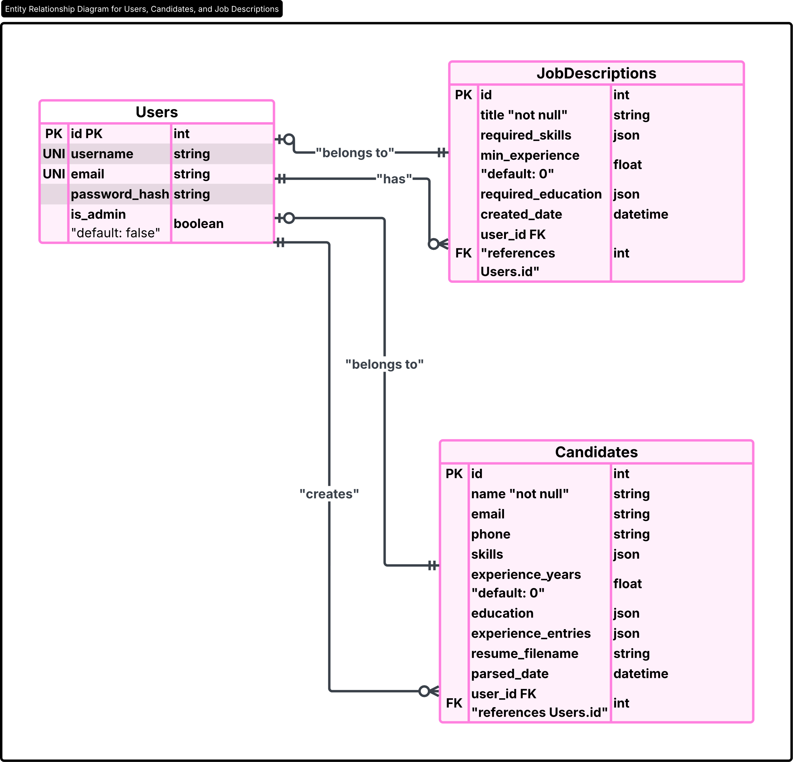
- Entity Relationship Diagram (ERD):

- Class Diagram:

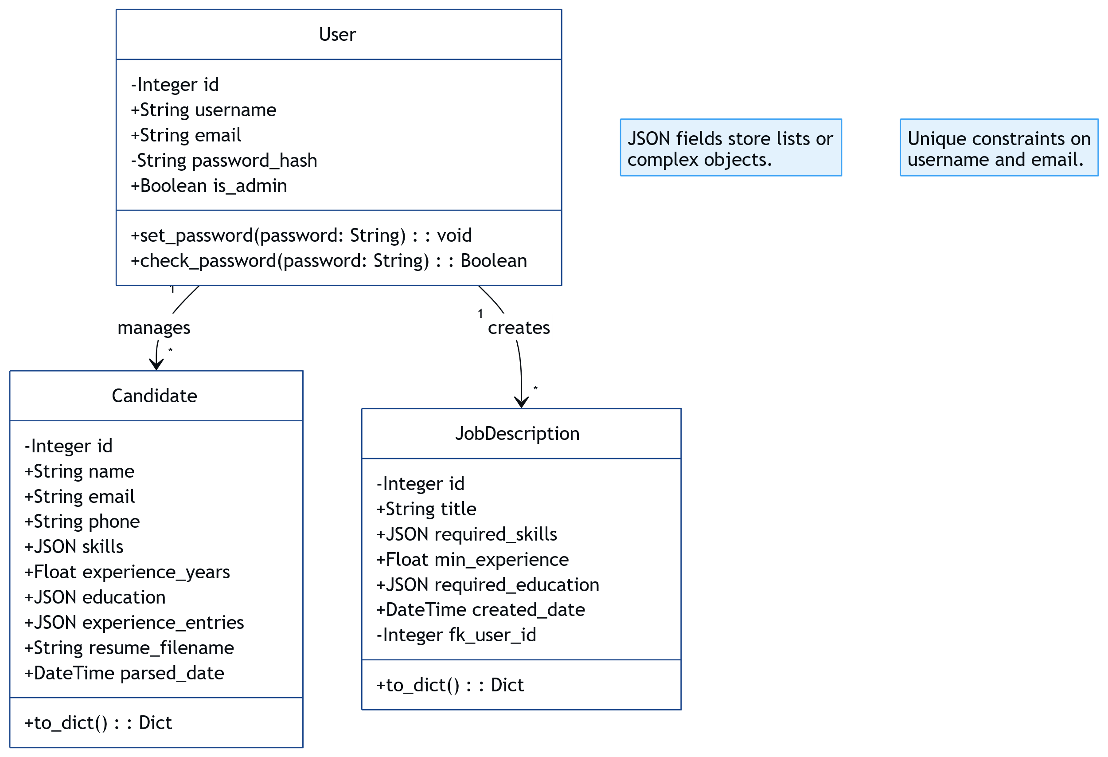

- Use Case Diagram:
  - Part 1 – User Management & Resume Handling

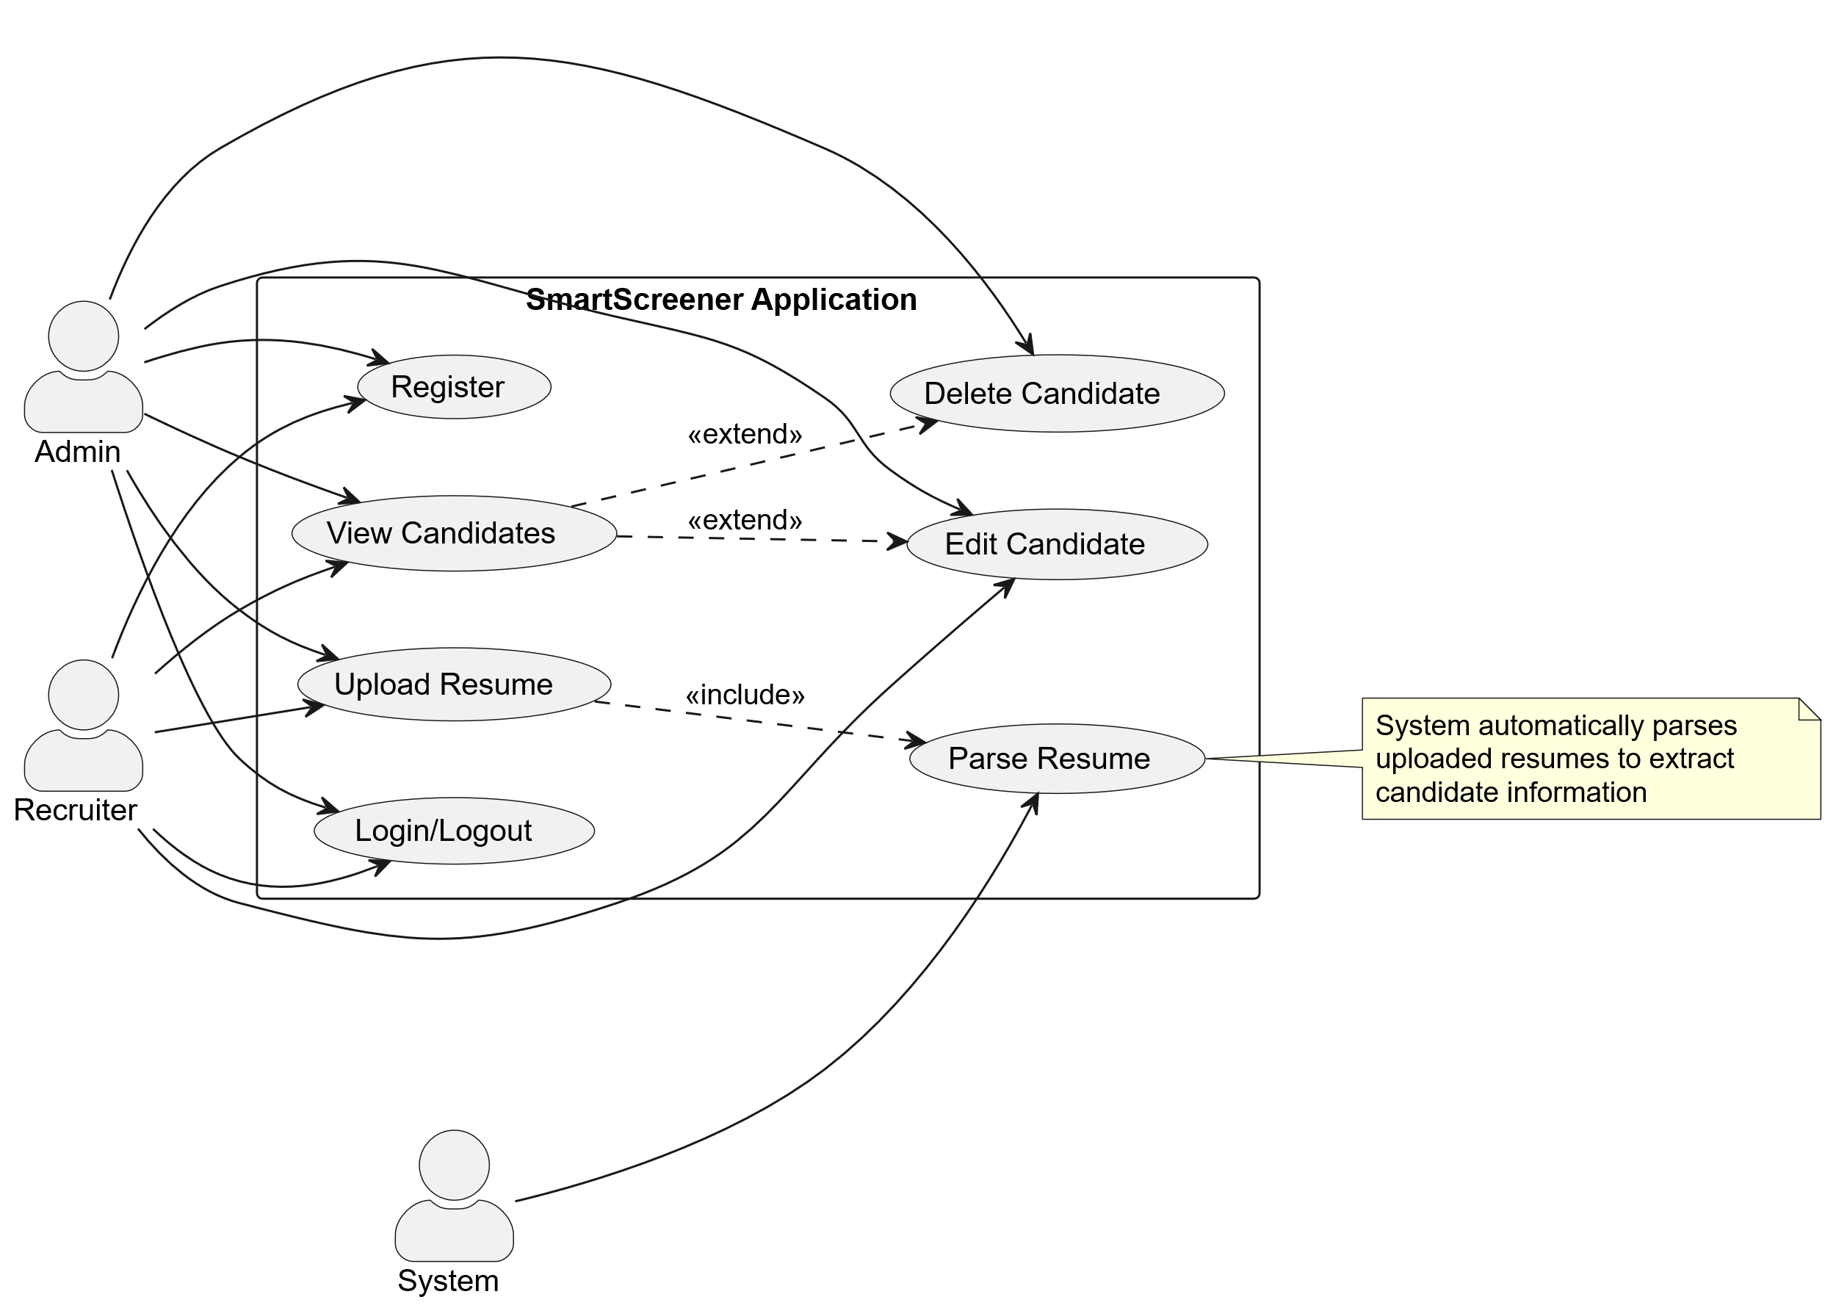

  - Part 2 – Job Descriptions & Matching
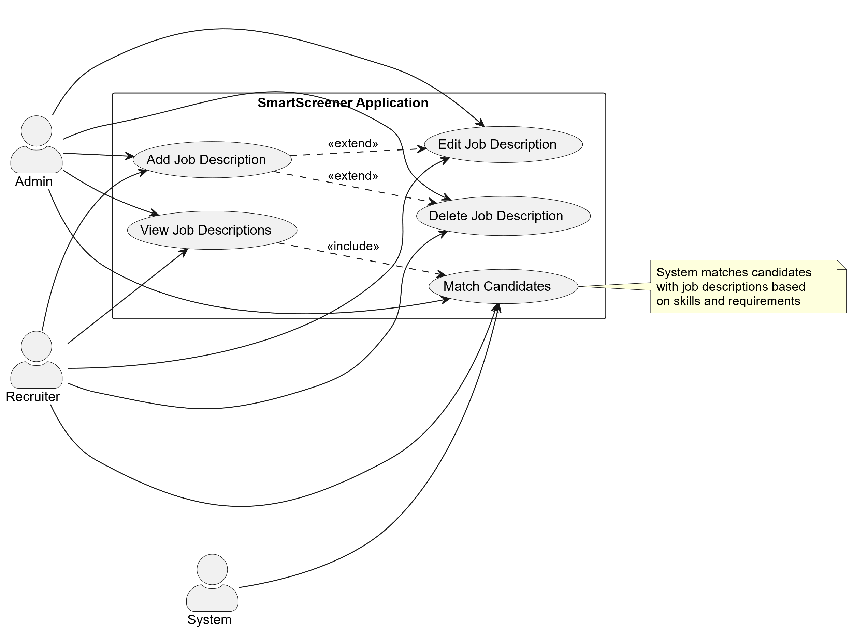

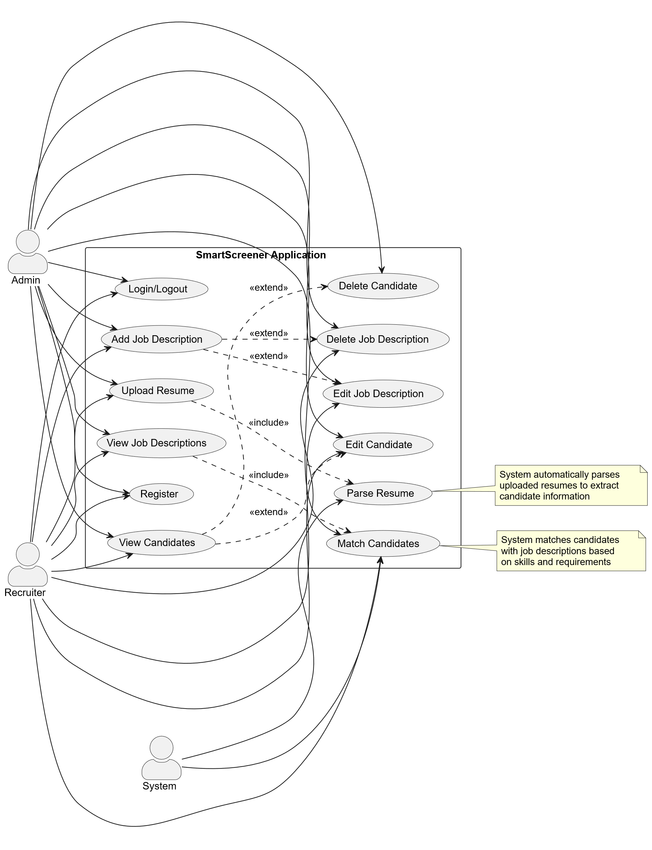
- Activity Diagram:

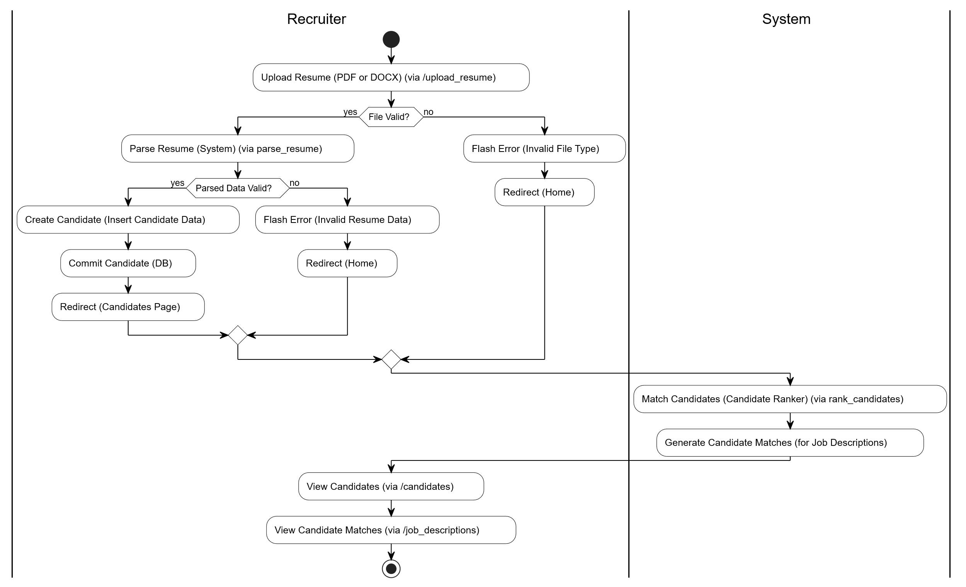
- Table Design:

- Data Dictionary:

- Login:

Column Name | Data Type | Key | Attributes
id | INT | PRIMARY KEY | AUTO_INCREMENT User ID
username | VARCHAR (80) | UNIQUE  KEY | NOT NULL
email | VARCHAR (120) | UNIQUE  KEY | NOT NULL
password_hash | VARCHAR (255) |  | HASHED PASSWORD
is_admin | BOOLEAN |  | ADMIN FLAG (DEFAULT FALSE)

Column Name | Data Type | KEY
Id | INT | PRIMARY KEY
Title | VARCHAR  (100)
required_skills | JSON
min_experience | FLOAT
required_education | JSON
created_date | DATETIME
User_id | INT | FOREIGN KEY
- JobDescription:

- Candidate:

Column Name | Data Type | KEY
id | INT | PRIMARY KEY
name | VARCHAR  (100)
email | VARCHAR  (100)
phone | VARCHAR  (20)
skills | JSON
experience_years | FLOAT
education | JSON
experience_entries | JSON
resume_filename | VARCHAR  (255)
parsed_date | DATETIME
User_id | INT | FOREIGN KEY
Foreign Key:
- `user_id` → `users(id)`

Drawbacks and Limitations:

- Limited File Format Support
- The system currently supports only PDF and DOCX resume formats. Resumes in other formats (e.g., TXT, RTF, images) cannot be processed.
- Parsing Accuracy Depends on Resume Structure
- The accuracy of information extraction is highly dependent on the formatting and structure of the uploaded resumes. Unconventional or poorly formatted resumes may lead to incorrect or incomplete data extraction.
- Language Limitation
- The resume parser is designed primarily for English-language resumes. Resumes in other languages may not be parsed correctly.
- Nuanced Information May Be Missed
- The system may not fully capture nuanced or context-specific information such as soft skills, achievements, or unique experiences that are not explicitly stated.
- Manual Verification Still Needed
- For critical or high-level positions, manual review and verification of candidate data may still be necessary to ensure accuracy and suitability.
- No Automated Reference or Background Checks
- The system does not perform automated reference checks or background verifications; these must be handled separately.
- Limited Integration
- The current version may not integrate seamlessly with all external HR systems, job portals, or applicant tracking systems (ATS).
- Scalability Constraints
- While suitable for small to medium organizations, very large-scale deployments may require further optimization for performance and database management.
- Security and Privacy Risks
- As with any system handling personal data, there is a risk of data breaches or unauthorized access if security best practices are not strictly followed.
- No Real-Time Collaboration
- The system does not support real-time collaboration or multi-user editing of candidate/job records.
- Limited Analytics
- Advanced analytics and reporting features may be basic or absent in the initial version.

Summary:

While SmartScreener automates and streamlines many aspects of resume screening, it is not a complete replacement for human judgment and may require enhancements to address the above limitations for broader or more complex use cases.

Proposed Enhancements:

- Support for Additional File Formats
- Enable parsing of resumes in more formats such as TXT, RTF, ODT, and even image-based resumes using OCR (Optical Character Recognition).
- Multi-Language Support
- Extend the resume parser to handle resumes written in multiple languages, broadening the system’s usability for global recruitment.
- Advanced AI-Based Matching
- Integrate machine learning and natural language processing (NLP) to better understand context, soft skills, and nuanced candidate qualifications for more accurate ranking.
- Integration with External Systems
- Provide APIs and connectors for seamless integration with popular HR management systems, job portals, and applicant tracking systems (ATS).
- Automated Reference and Background Checks
- Incorporate modules to automate reference checks, background verification, and credential validation.
- Real-Time Collaboration
- Allow multiple recruiters or administrators to collaborate in real-time, comment on candidate profiles, and share feedback within the system.
- Enhanced Analytics and Reporting
- Add advanced analytics dashboards for tracking recruitment metrics, diversity statistics, and process bottlenecks, with customizable report generation.
- Mobile Application
- Develop a mobile app version for recruiters to manage candidates and job postings on the go.
- Candidate Feedback System
- Implement a feedback mechanism for candidates to receive updates and feedback on their application status.
- Automated Interview Scheduling
- Integrate calendar and email services to automatically schedule interviews with shortlisted candidates.
- Improved Security and Compliance
- Enhance data encryption, add audit trails, and ensure compliance with data protection regulations such as GDPR.
- Customizable Workflow
- Allow organizations to customize the recruitment workflow, add custom fields, and define their own evaluation criteria.
- Bulk Operations
- Enable bulk upload, edit, and deletion of candidate records and job descriptions for easier management.

Summary:

These enhancements will make Smart Resume Screener more robust, flexible, and suitable for a wider range of organizations and recruitment needs, while also improving user experience, security, and integration capabilities.

Conclusion:

Smart Resume Screener provides an innovative and efficient solution to the challenges faced in traditional resume screening and candidate evaluation processes. By automating the extraction, organization, and ranking of candidate information, the system significantly reduces the time and effort required for recruitment, minimizes human bias, and ensures a more consistent and objective evaluation of applicants.
The platform’s user-friendly interface, secure data management, and automated matching capabilities empower recruiters and administrators to make better hiring decisions and improve overall recruitment quality. While the current system addresses many pain points of manual screening, it also lays a strong foundation for future enhancements such as advanced AI-based matching, multi-language support, and deeper integration with external HR systems.
In summary, Smart Resume Screener streamlines the recruitment workflow, enhances decision-making, and positions organizations to attract and select the best talent efficiently. With ongoing improvements and the adoption of proposed enhancements, Smart Resume Screener has the potential to become an indispensable tool for modern, data-driven recruitment.

Bibliography:

    - Flask Documentation
Flask: Web Development, One Drop at a Time.
URL: Welcome to Flask — Flask Documentation (3.1.x)

    - SQLAlchemy Documentation
SQLAlchemy: The Database Toolkit for Python.
URL: Overview — SQLAlchemy 2.0 Documentation

    - MySQL 8.0 Reference Manual
MySQL Documentation.
URL: MySQL :: MySQL 8.4 Reference Manual

    - Bootstrap Documentation
Bootstrap: The most popular HTML, CSS, and JS library.
URL: Get started with Bootstrap · Bootstrap v5.3

    - Werkzeug Documentation
Werkzeug: A WSGI utility library for Python.
URL: Werkzeug — Werkzeug Documentation (3.1.x)

    - Jinja Documentation
Jinja: A modern and designer-friendly templating language for Python.
URL: Jinja — Jinja Documentation (3.1.x)

    - Resume Parser Library
Various open-source resume parsing libraries and resources.
Example: OmkarPathak/pyresparser: A simple resume parser used for extracting information from resumes

    - General Python Documentation
Python Software Foundation.
URL: 3.13.3 Documentation
ANNEXURES:

- ANNEXURE 1: USER INTERFACE SCREENS

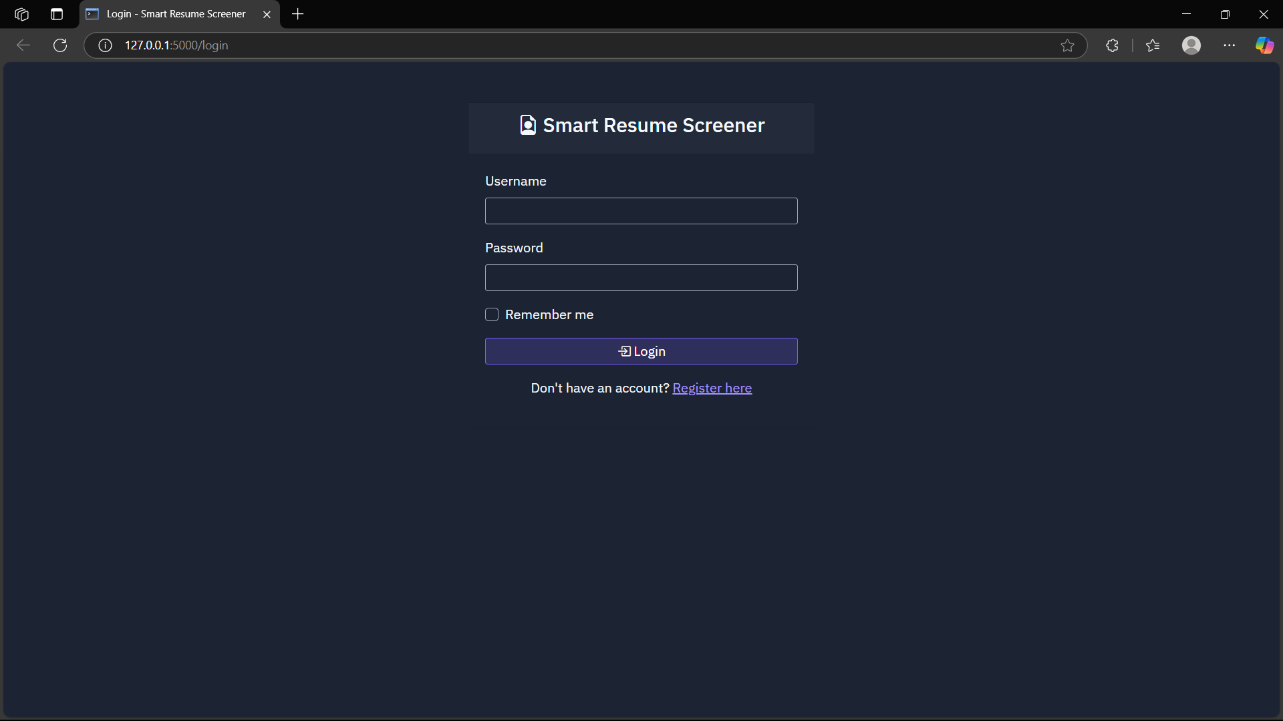
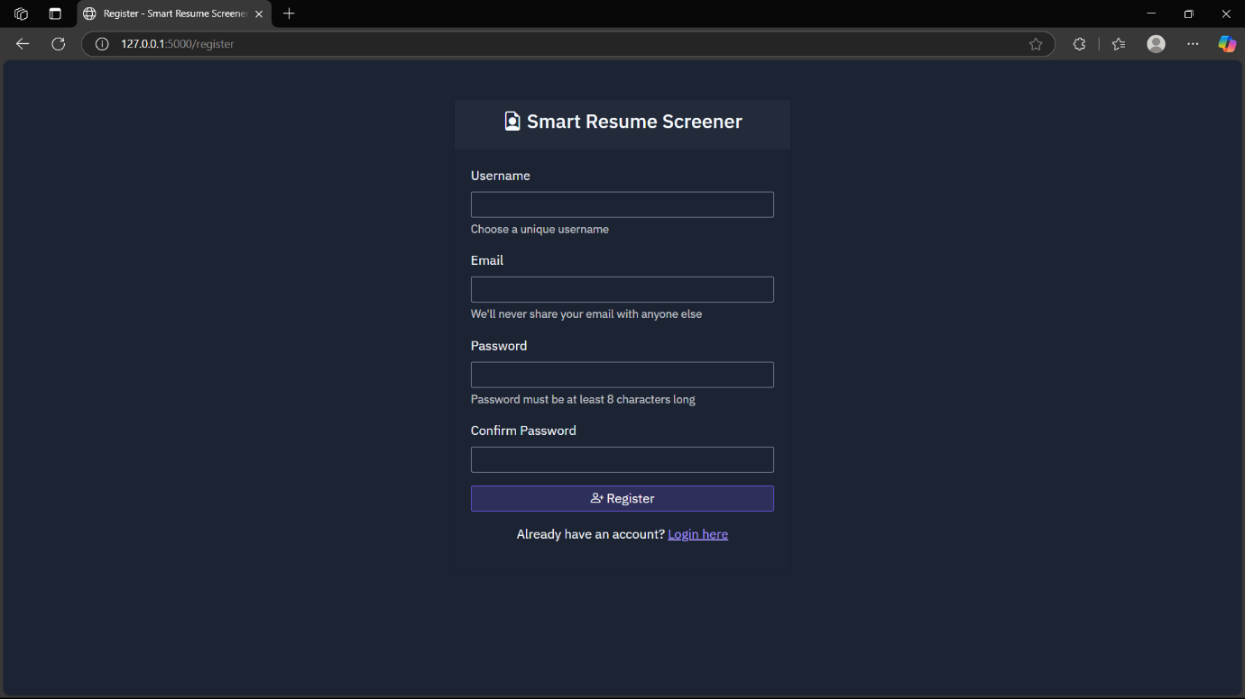

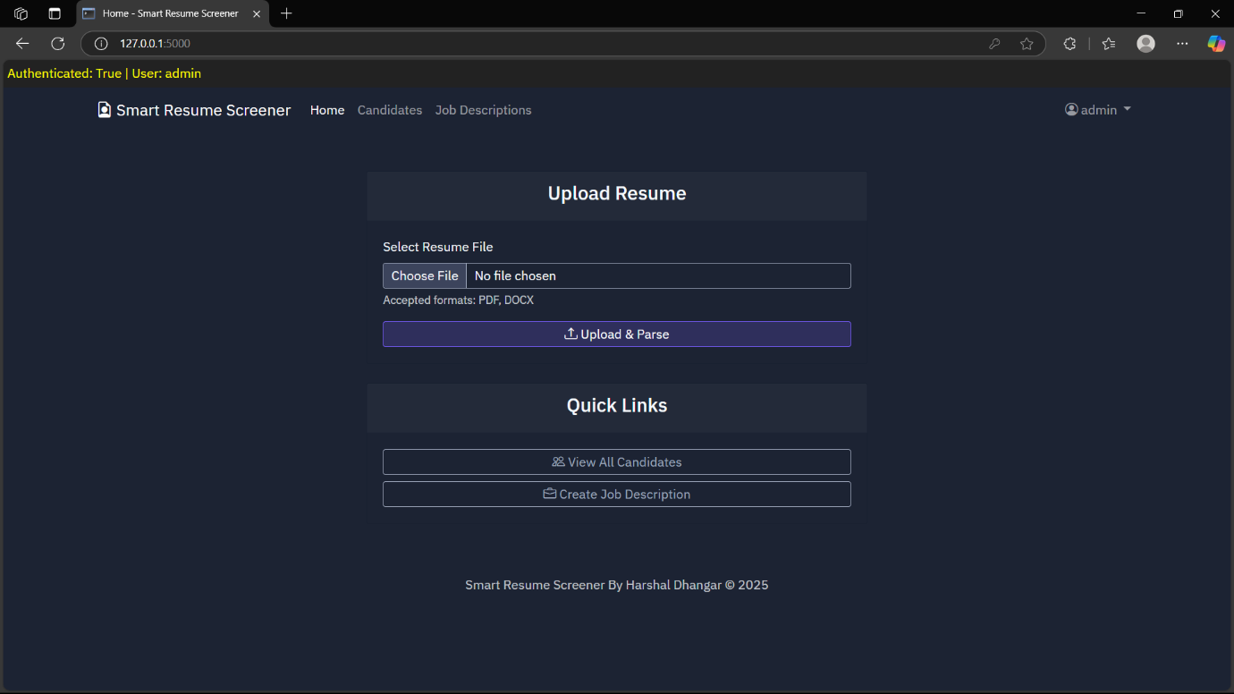

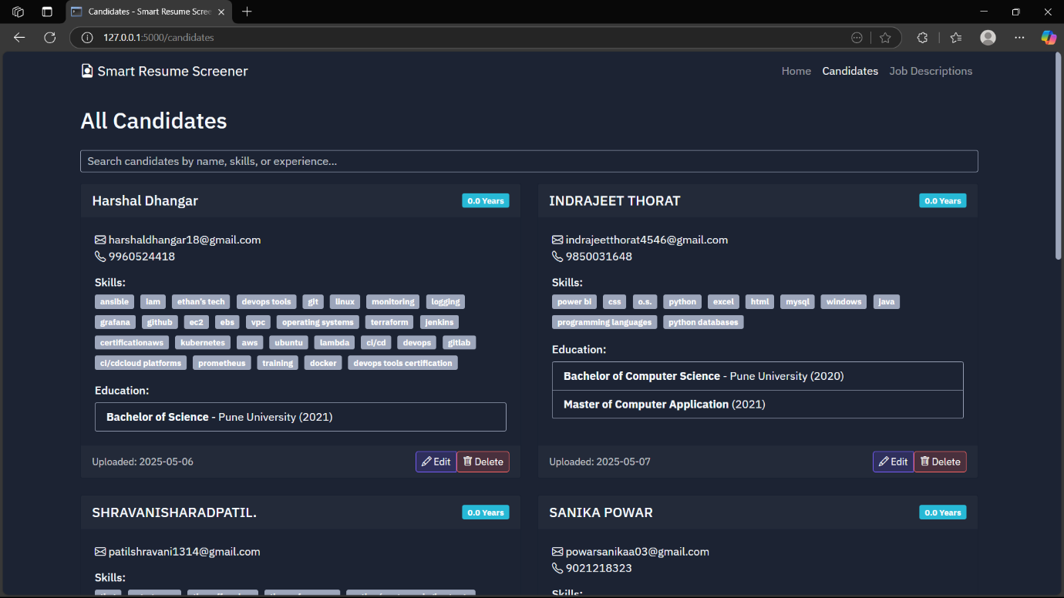
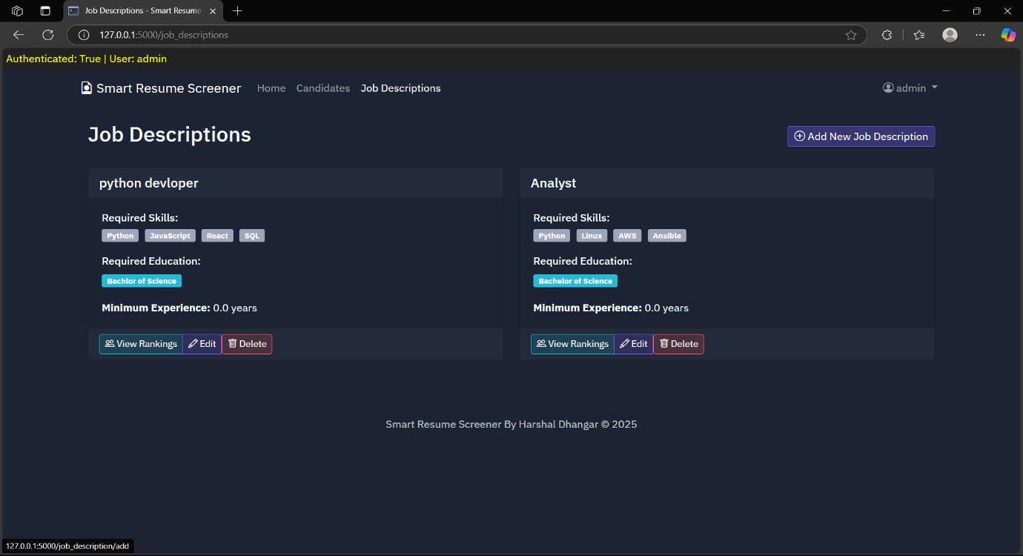
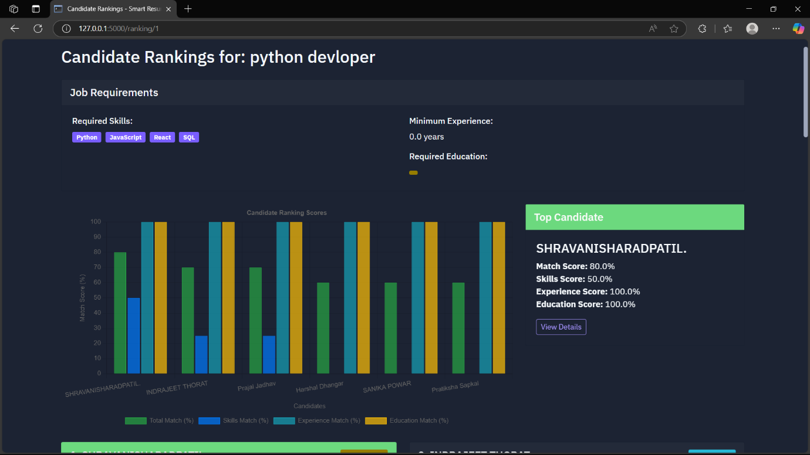
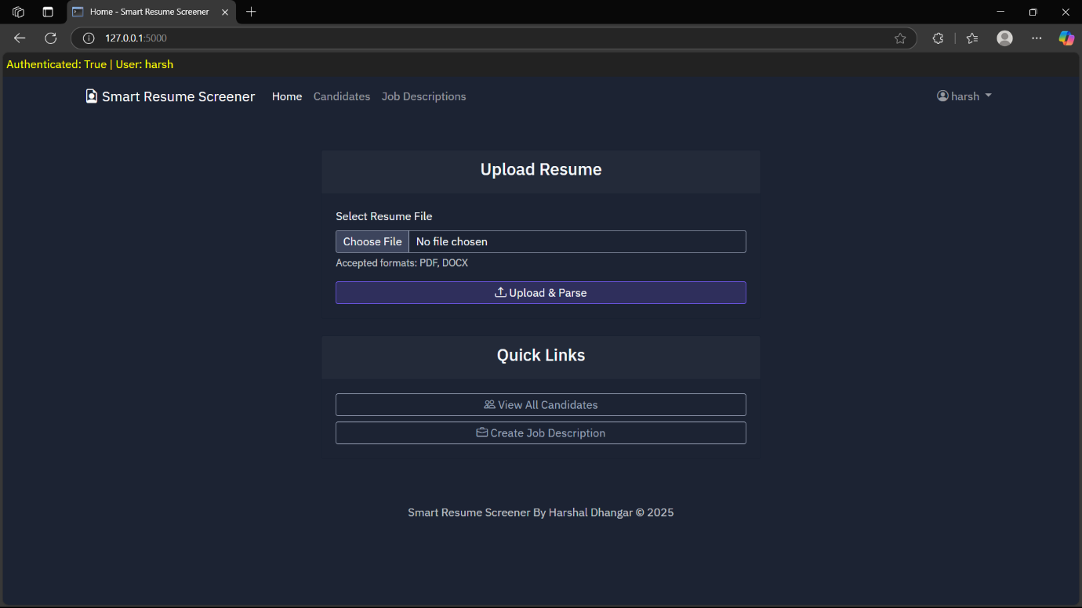
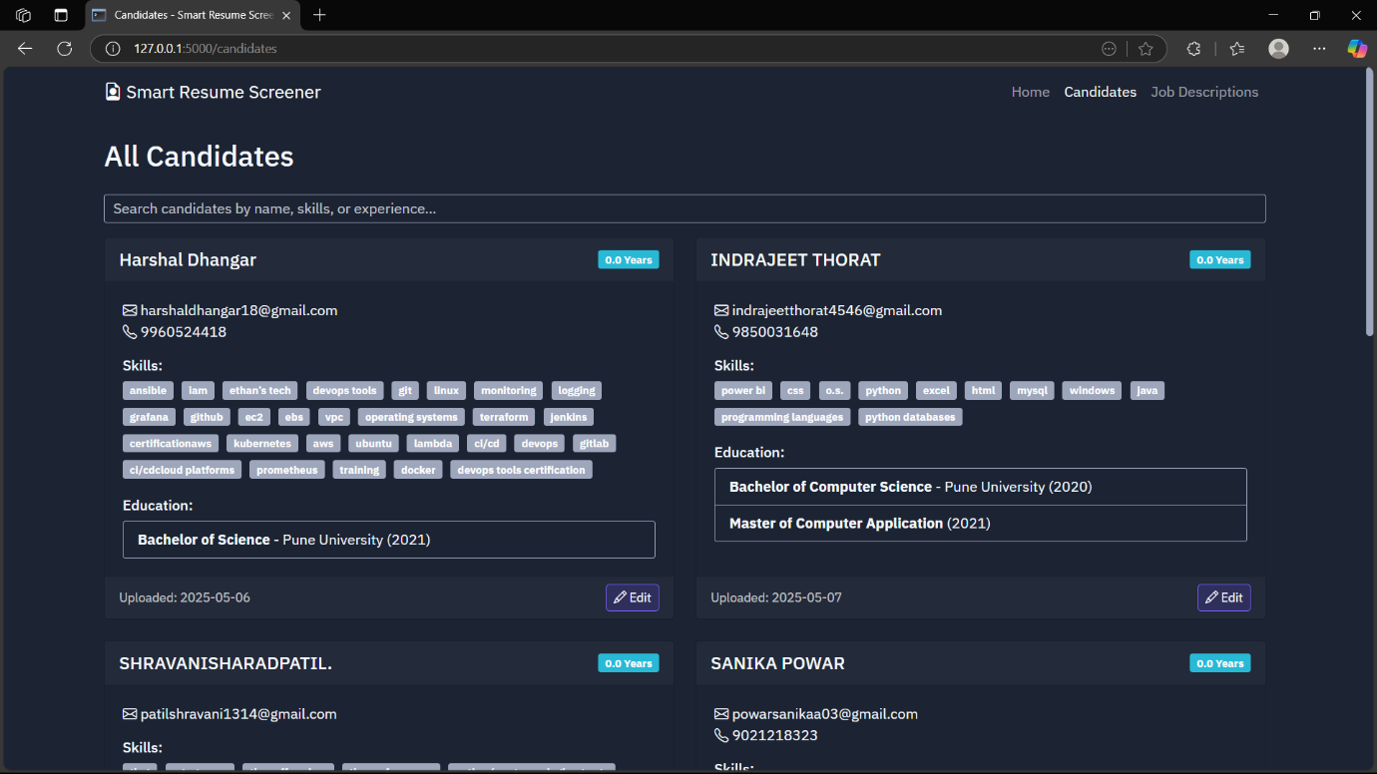

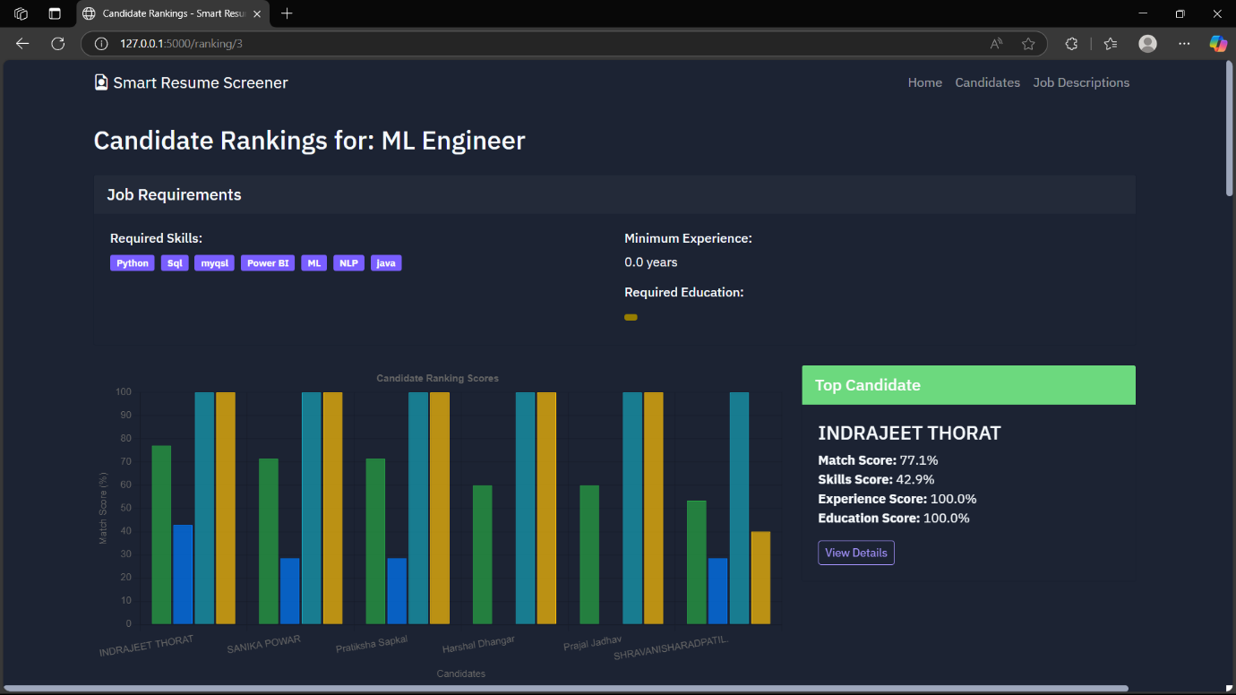
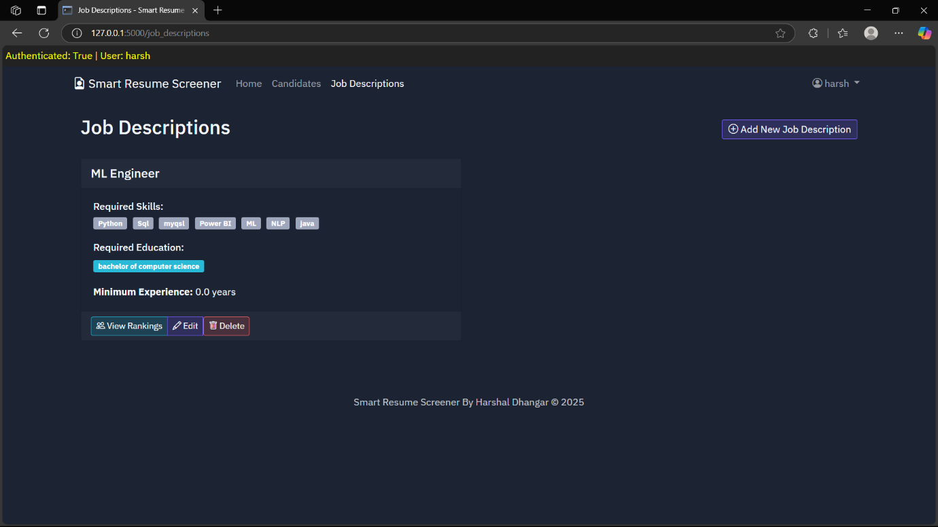

Thank You

